

R E S U M E

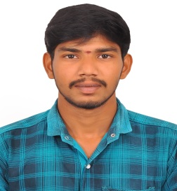
P.KIRUBAHARAN S/o PALANISAMY,
2/76, Kupprikkapalayam, Perunkurichi Post, Paramathi Velur Tk, Namakkal Dt,
Pin :637 201

E-mail : kirubaharan150@gmail.com Mobile : +91-9345738295

OBJECTIVE

To seek an opportunity organization and venture to be a part of its growth through innovative and dedicated approach to the challenges and thereby upgrade my skills with hard work and sincerity.

ACADEMIC PROFILE

DEGREE/COURSE | INSTITUTE | YEAR OF PASSING | PERCENTAGE
B.A(TAMIL) | Tiruvalluvar Govt.College of Arts and Science, Rasipuram | 2018 | 64%
H.S.C | M.D.V Hr. Sec School Tiruchengode | 2015 | 70%
SSLC | Government Hr. Sec School Kandampalayam | 2013 | 54%

EX
EXTRA CURRICULAR ACTIVITIES

- I have completed SHINE V Pre-Board Exam in 2015

- I have Participated Computer Science Exam in periyar university

- I have Participated Tally Exam in M.D.V Hr. Sec School

Document Writter office Tiruchengode - 5 year
EXPERIENCE

PERSONAL DETAILS
Name : P.KIRUBAHARAN
Father Name : Palanisamy
Mother Name : Valarmathi
Date of Birth : 28.06.1998
Age : 28
Sex : Male
Blood group : O+
Married Status : married
Nationality : Indian
Religion : Hindu
Languages : Tamil and English.


DECLARATION
I hereby declare that, the above information furnished by me is correct up to my knowledge and I hear the responsibility for the correctness of the above mentioned particulars.

Place: SIGNATURE
Date : (P.KIRUBAHARAN)

